 

G H Patel College of Engineering & Technology

**(A Constituent College of CVM University) Bakrol, Anand.**

# COMPUTER ENGINEERING DEPARTMENT

**Project Report on**

***Salon Website***

# Submitted By

**Name of Student:**

**Aryan Prajapati (12202130501005)**

# Python and Web Programming (202045612)

**A.Y. 2024-25 ODD TERM**

## Introduction:

Your salon website project sounds well-organized with essential features for user interaction and management. Using Django for the backend provides robust support for handling user authentication, updating profiles, and data management. Here’s a brief overview of each section for your introduction:

* **Home**: Welcomes users to the salon and showcases highlights or promotions.
* **About**: Shares the salon's story, mission, and team information.
* **Services**: Lists services offered, with descriptions, prices, and possibly booking options.
* **Salon**: Provides a gallery or virtual tour of the salon.
* **Contact**: Contains contact details, a form for inquiries, and possibly a map for easy location access.
* **Login/Signup**: Allows users to create accounts, log in, and access personalized features.

The functionality you've implemented will enhance user experience, as they can easily manage their profiles, view their data, and even delete accounts if needed. This setup should offer users a seamless experience with all the essential elements of a professional salon website.

## Pages Overview:

## Home Page (home.html)

* **Banner Section**: The main banner introduces the salon's address and brand message, with buttons for "Get Gorgeous" and "Contact Now" linking to the contact page for easy access.
* **Image Carousel**: A stylish image section displays salon models, welcoming visitors and highlighting the salon's ambiance.
* **Service Highlights**: Lists salon services (e.g., Haircuts, Beards & Shaves, Coloring, Waxing) with prices, giving users a clear view of service offerings.
* **Social Media Links**: Social media icons link to Instagram, Google, and Facebook, encouraging users to follow and engage online.
* **Reviews Section**: Invites users to leave reviews, helping build credibility and user interaction.

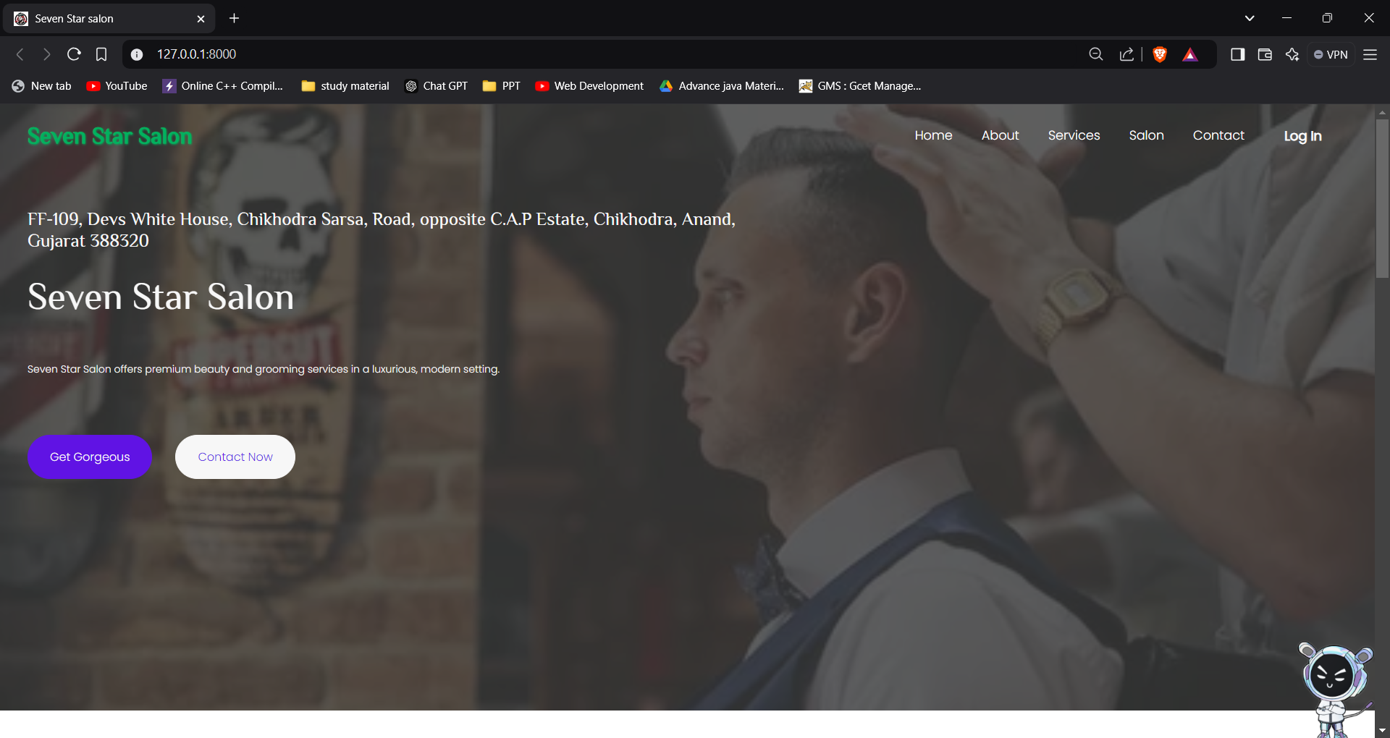

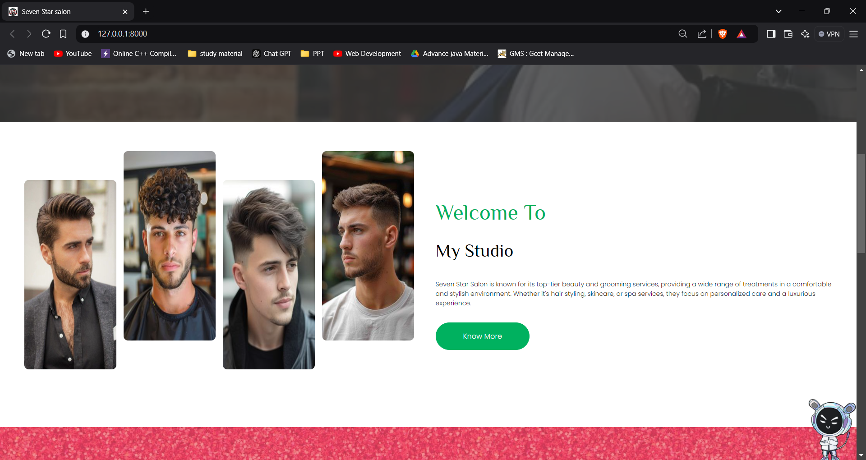

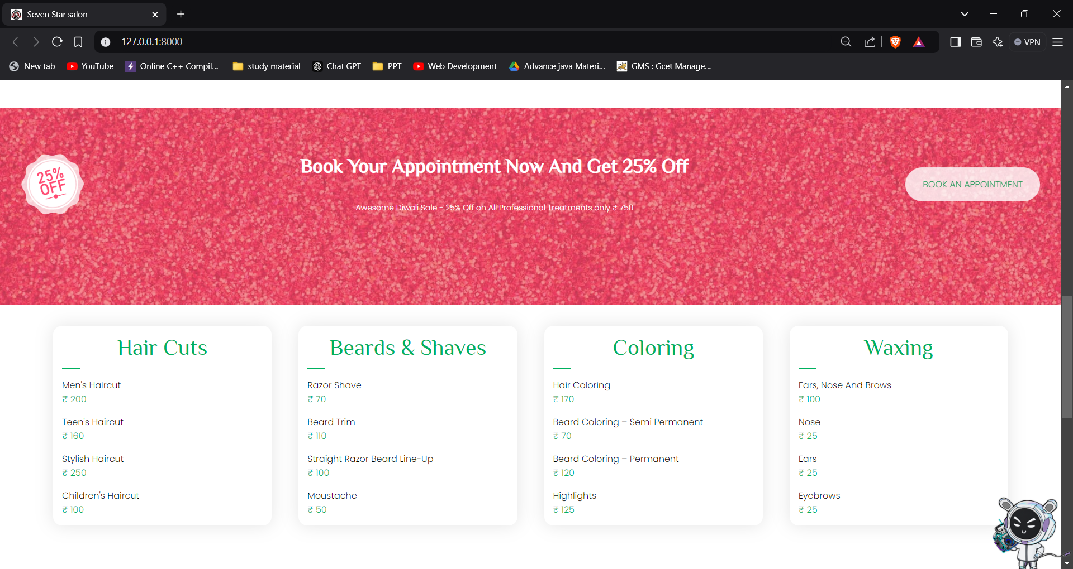

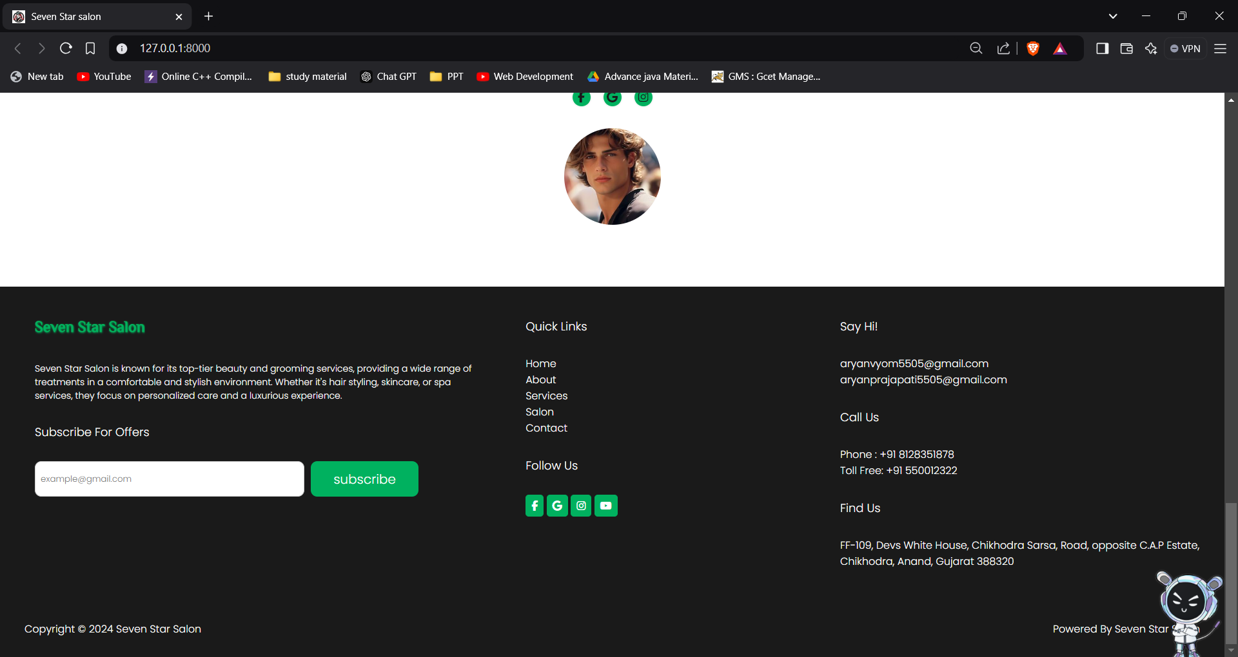

1. **Sign-In Page (signin.html)**

* **User Login Form**: The form enables existing users to log in with username and password. Validation feedback appears if login details are incorrect.
* **Visual Feedback**: The page displays a red error message if login fails, providing feedback to enhance user experience.
* **Styled Avatar Image**: A welcoming avatar image adds a personal touch to the login interface.

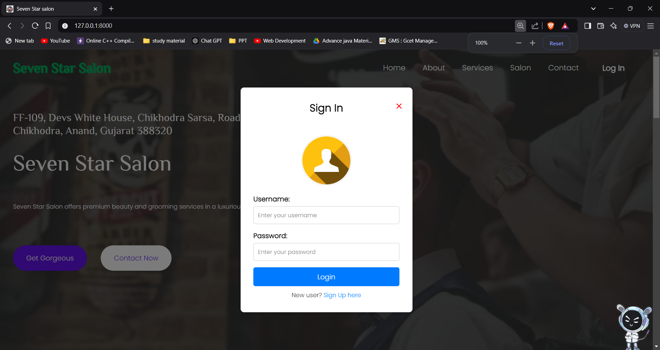

1. **Sign-up Page (signup.html)**

* **User Registration Form**: New users can register by providing essential information such as first and last names, username, birthdate, mobile number, email, and password.
* **Validation**: The form validates user inputs (e.g., name length, mobile number format, password length), ensuring data accuracy and minimizing errors.
* **User-Friendly Interface**: Error messages appear via alerts, guiding users to correct mistakes before submission.
* **Styling Consistency**: The form includes an avatar image, aligning with the website's visual theme, which enhances the brand experience.

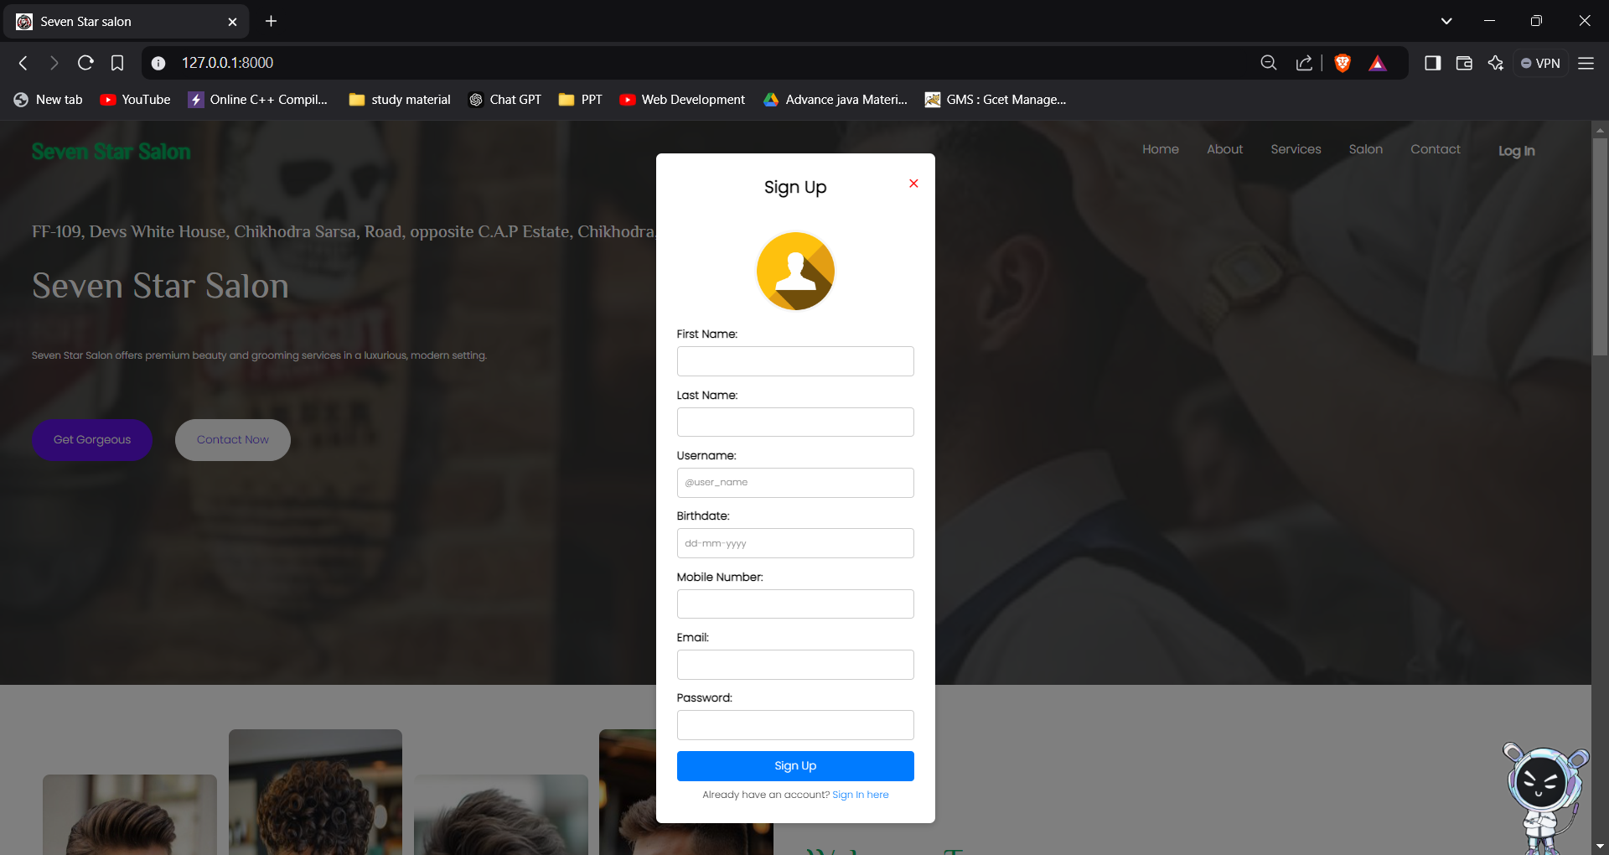

1. **About(about.html)**

### Introduction

The **About** page of the "Seven Star Salon" website introduces the story and mission behind the salon. This page is designed to connect with customers by highlighting the salon owner’s background and passion for hairdressing, as well as showcasing the dedicated team that brings the salon's vision to life. With elegant styling and engaging content, this page emphasizes the salon's commitment to providing personalized and high-quality grooming experiences.

### Page Features

1. **About Section**:
   * **Personal Story**: Shares the inspiring journey of the salon's owner, "Prem Sen," detailing his dedication and evolution as a hairstylist and salon owner. This section adds a personal touch, helping customers connect with the salon's roots.
   * **Owner's Contact Information**: Displays the owner's phone number and email address with icons, providing an easy way for clients to get in touch directly.
   * **Owner's Image**: Includes a high-quality image of the owner to personalize the page further and create a welcoming experience.
2. **Our Awesome Team Section**:
   * **Team Overview**: Highlights the team of skilled professionals who contribute to the salon’s success, enhancing client confidence in the services provided.
   * **Team Member Profiles**: Displays images of each team member along with their names and roles (e.g., Founder, Support Team), showcasing the friendly and approachable staff who contribute to the customer experience.
   * **Stylized Layout**: The team section features a visually pleasing grid layout for each team member, maintaining consistency with the salon's branding and visual appeal.

This **About** page strengthens the salon's brand by introducing the personalities behind the business, building trust and relatability, and emphasizing a commitment to quality service.

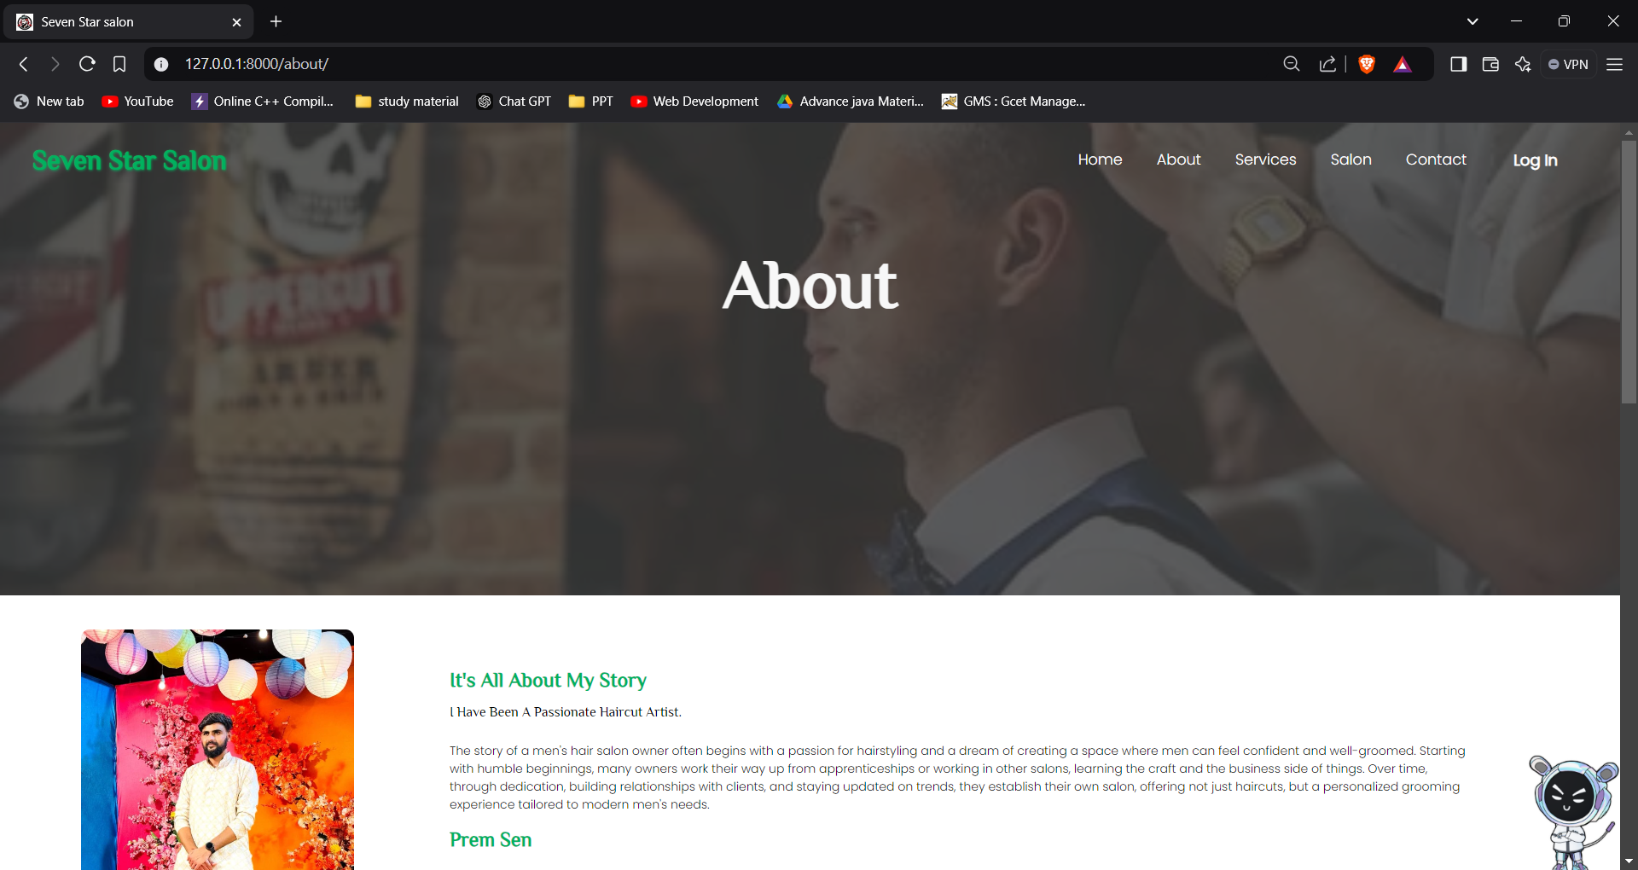

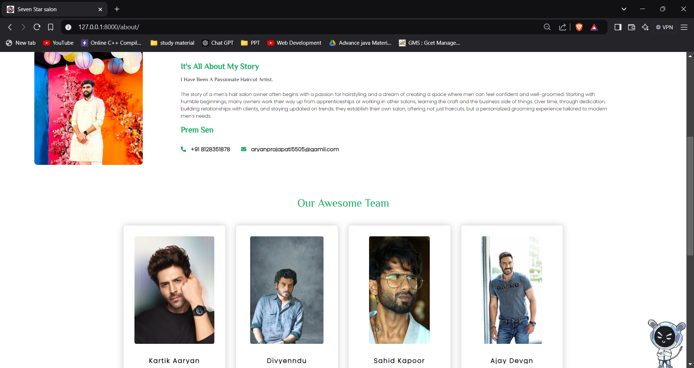

1. **Salon(salon.html)**

### Introduction

The **Salon** page of the "Seven Star Salon" website serves as a visually engaging showcase of the salon’s atmosphere, facilities, and services. This page provides potential clients with an inside look at the salon through a gallery of high-quality images. It also features promotional offers to attract customers, making it a useful tool for highlighting the salon's aesthetic appeal and ongoing deals.

### Page Features

1. **Hero Section**:
   * Displays the page title "Salon" prominently to introduce users to the salon's environment, setting the tone for the rest of the page.
2. **Image Gallery**:
   * **Visual Showcase**: Features a carefully curated gallery of images showcasing different areas and services offered at the salon. This helps potential clients envision the salon’s ambiance, facilities, and quality of service.
   * **High-Quality Photos**: Each image in the gallery offers a glimpse of the salon's interiors and styling services, designed to inspire confidence in the salon's professional standards and welcoming environment.
3. **Discount Section**:
   * **Embedded Promotional Offers**: Includes a dedicated section for discounts via an embedded template (discount.html), making it easy to update promotions.
   * **Engagement Incentives**: By showcasing ongoing deals, this section encourages users to take advantage of special offers, enhancing customer engagement and driving traffic to the salon.
4. **Consistent Layout and Styling**:
   * The page uses a consistent layout, color scheme, and styling to align with the overall branding of the "Seven Star Salon" website, ensuring a cohesive user experience across different pages.

This **Salon** page effectively combines aesthetic appeal and functionality, using visuals and promotions to attract and engage visitors while strengthening the salon's brand identity.

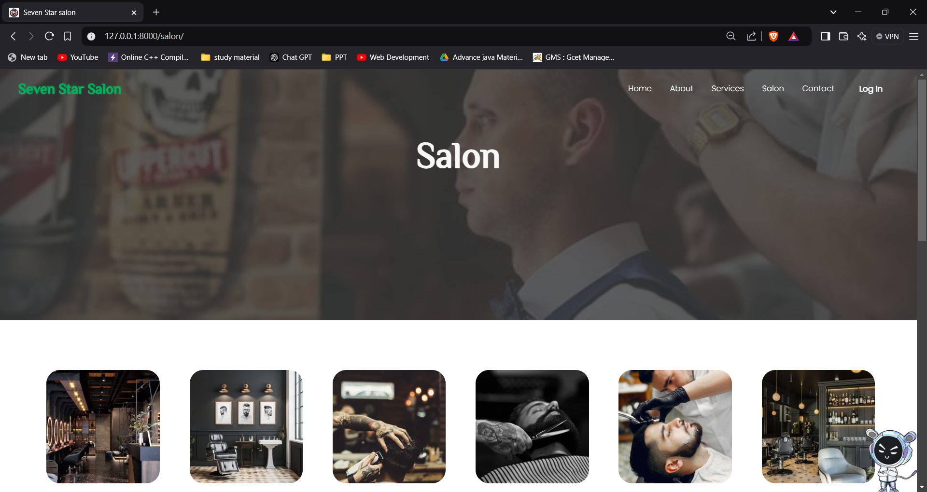

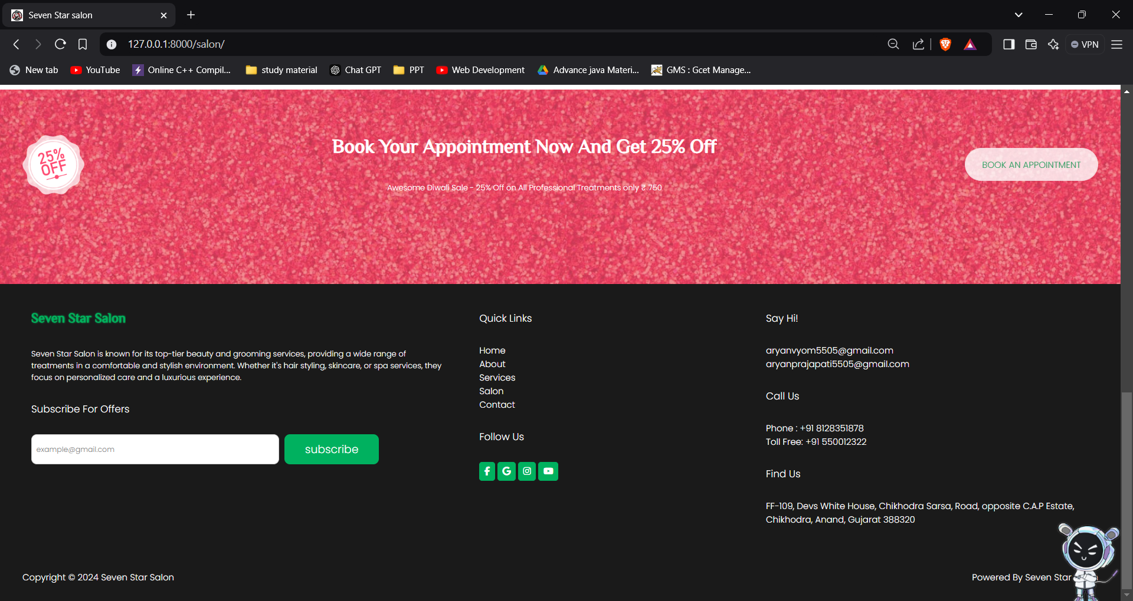

1. **Services(services.html)**

### Introduction

The **Services** page of the "Seven Star Salon" website is designed to present a detailed and visually appealing overview of the salon's offerings. From haircuts to specialized face treatments, this page enables clients to browse through a variety of services available at the salon. Each service is highlighted with an image and a short description, creating a user-friendly experience that helps clients understand the range of options.

### Page Features

1. **Hero Section**:
   * Displays the title "Services" at the top, setting a clear and welcoming tone for users as they explore the salon's offerings.
2. **Service Collection Section**:
   * **"Choose From Collection" Heading**: A brief introduction that encourages clients to explore the various services.
   * **Service Boxes**: Each service is showcased in a box with an image and a short description.
     + **Images**: High-quality images give clients a visual reference for each service, making the page engaging and informative.
     + **Service Name and Description**: Each service is labeled with a name (e.g., "Hair Cut," "Hair Wash") and accompanied by a brief description to provide more context.
3. **Discount Section**:
   * **Promotional Offers**: A dedicated section highlights any discounts or offers available, driving interest and providing clients with incentives to book services.
4. **Consistent Styling and Layout**:
   * The page is styled to match the salon's overall aesthetic, creating a cohesive user experience across the site.

This **Services** page is both informative and visually appealing, providing a comprehensive yet accessible overview of the salon's offerings. The combination of high-quality images, concise descriptions, and promotional highlights creates a professional, engaging experience for users.

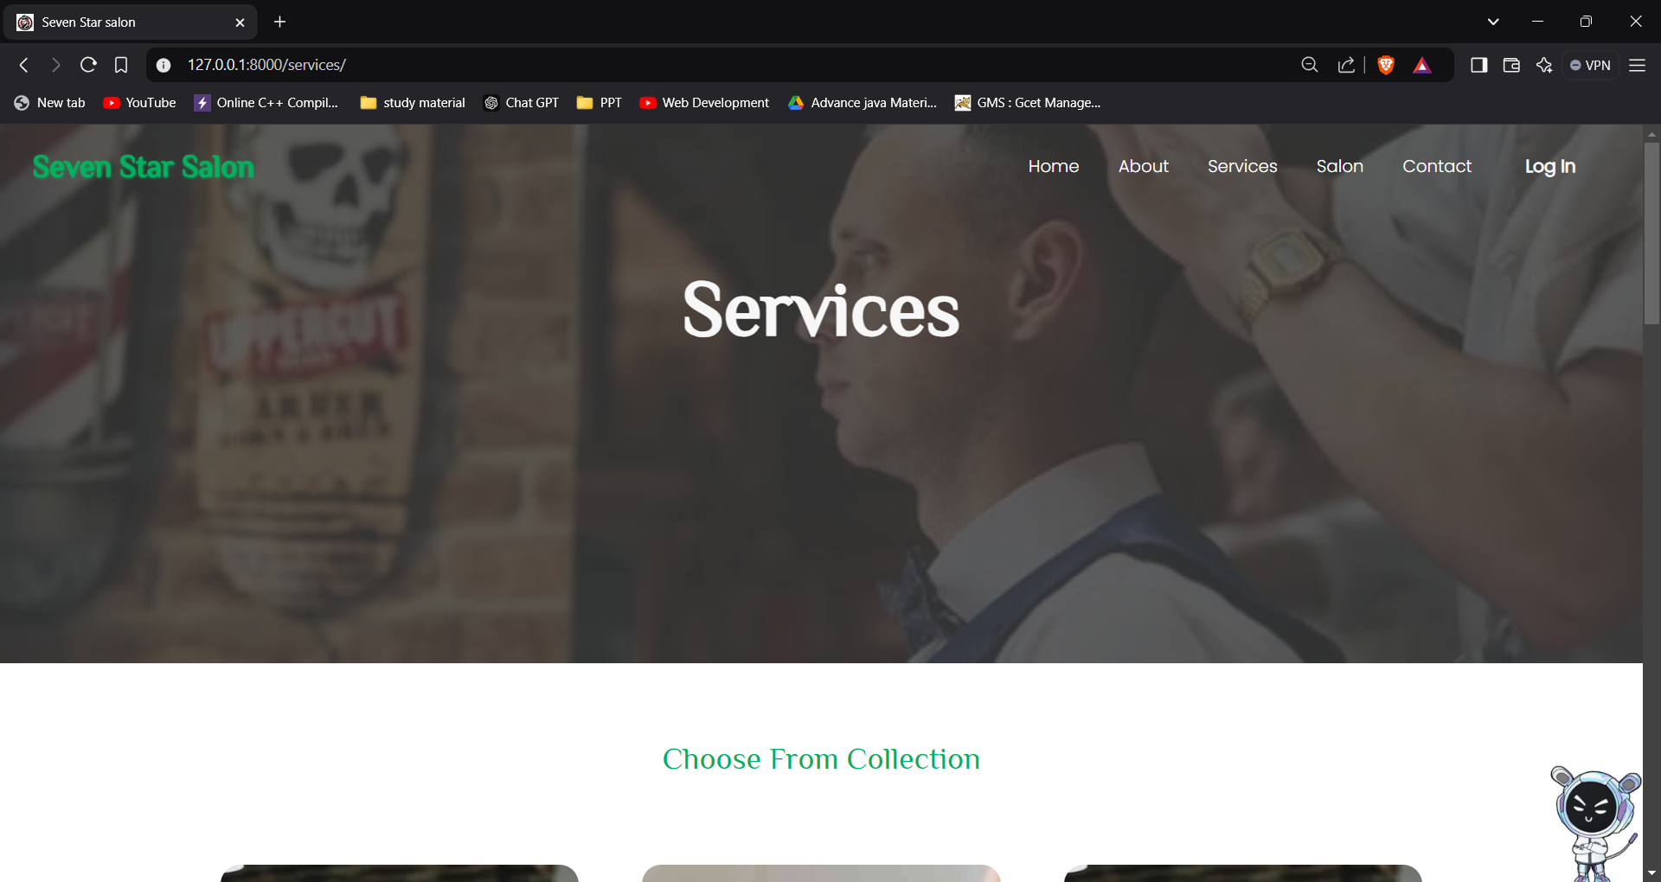

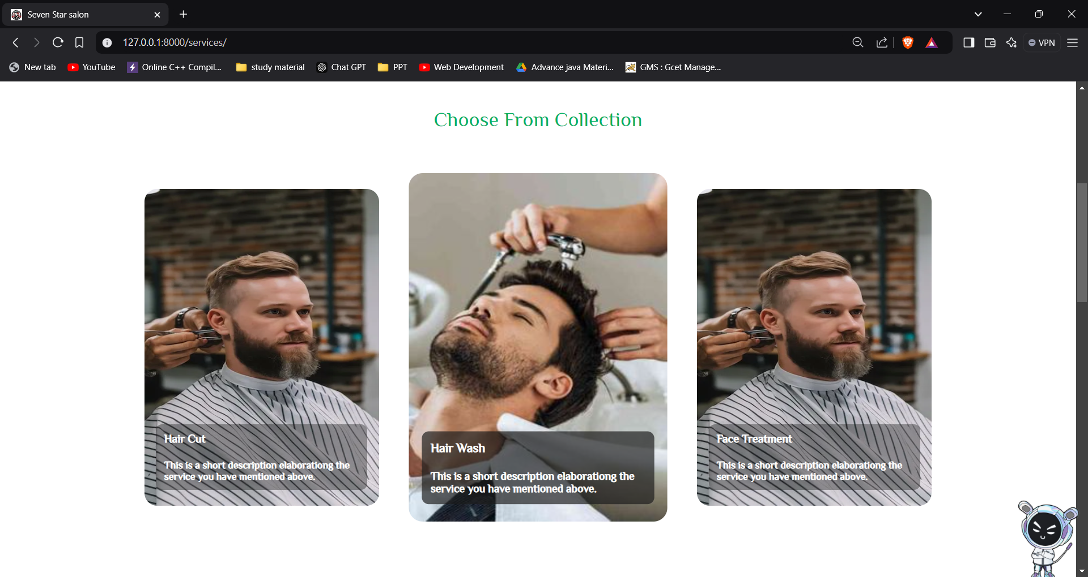

1. **Contact(contact.html)**

### Introduction

The **Contact Us** page of the "Seven Star Salon" website allows clients to easily reach out for inquiries or service requests. This page provides a contact form for submitting messages and a Google Maps embed showing the salon's location, making it straightforward for clients to connect with the salon team and find their way there.

### Page Features

1. **Hero Section**:
   * Displays "Contact Us" at the top, immediately orienting users to the purpose of the page.
2. **Contact Form**:
   * **Form Fields**: Includes fields for the client's name, phone number, email, and message, ensuring that all essential information is collected.
   * **Service Selection**: Clients can choose from a dropdown list of services (e.g., Hair Color, Hair Styling), allowing the salon to understand their specific needs.
   * **Submit Button**: Once completed, the form can be submitted for further processing via the "Send Request" button.
   * **Confirmation Alert**: After submission, the page checks URL parameters to display a success or error message, ensuring clients are informed about the status of their request.
3. **Google Map Embed**:
   * A live Google Map embed provides the exact location of the salon, making it easy for clients to navigate to the salon.
4. **Dynamic Feedback**:
   * JavaScript is used to trigger pop-up alerts confirming the success or failure of the form submission, enhancing the user experience.

This **Contact Us** page is both practical and user-friendly, ensuring that clients have a seamless experience reaching out to the salon for inquiries, bookings, or directions. The inclusion of a Google Map adds a helpful visual for in-person visits.

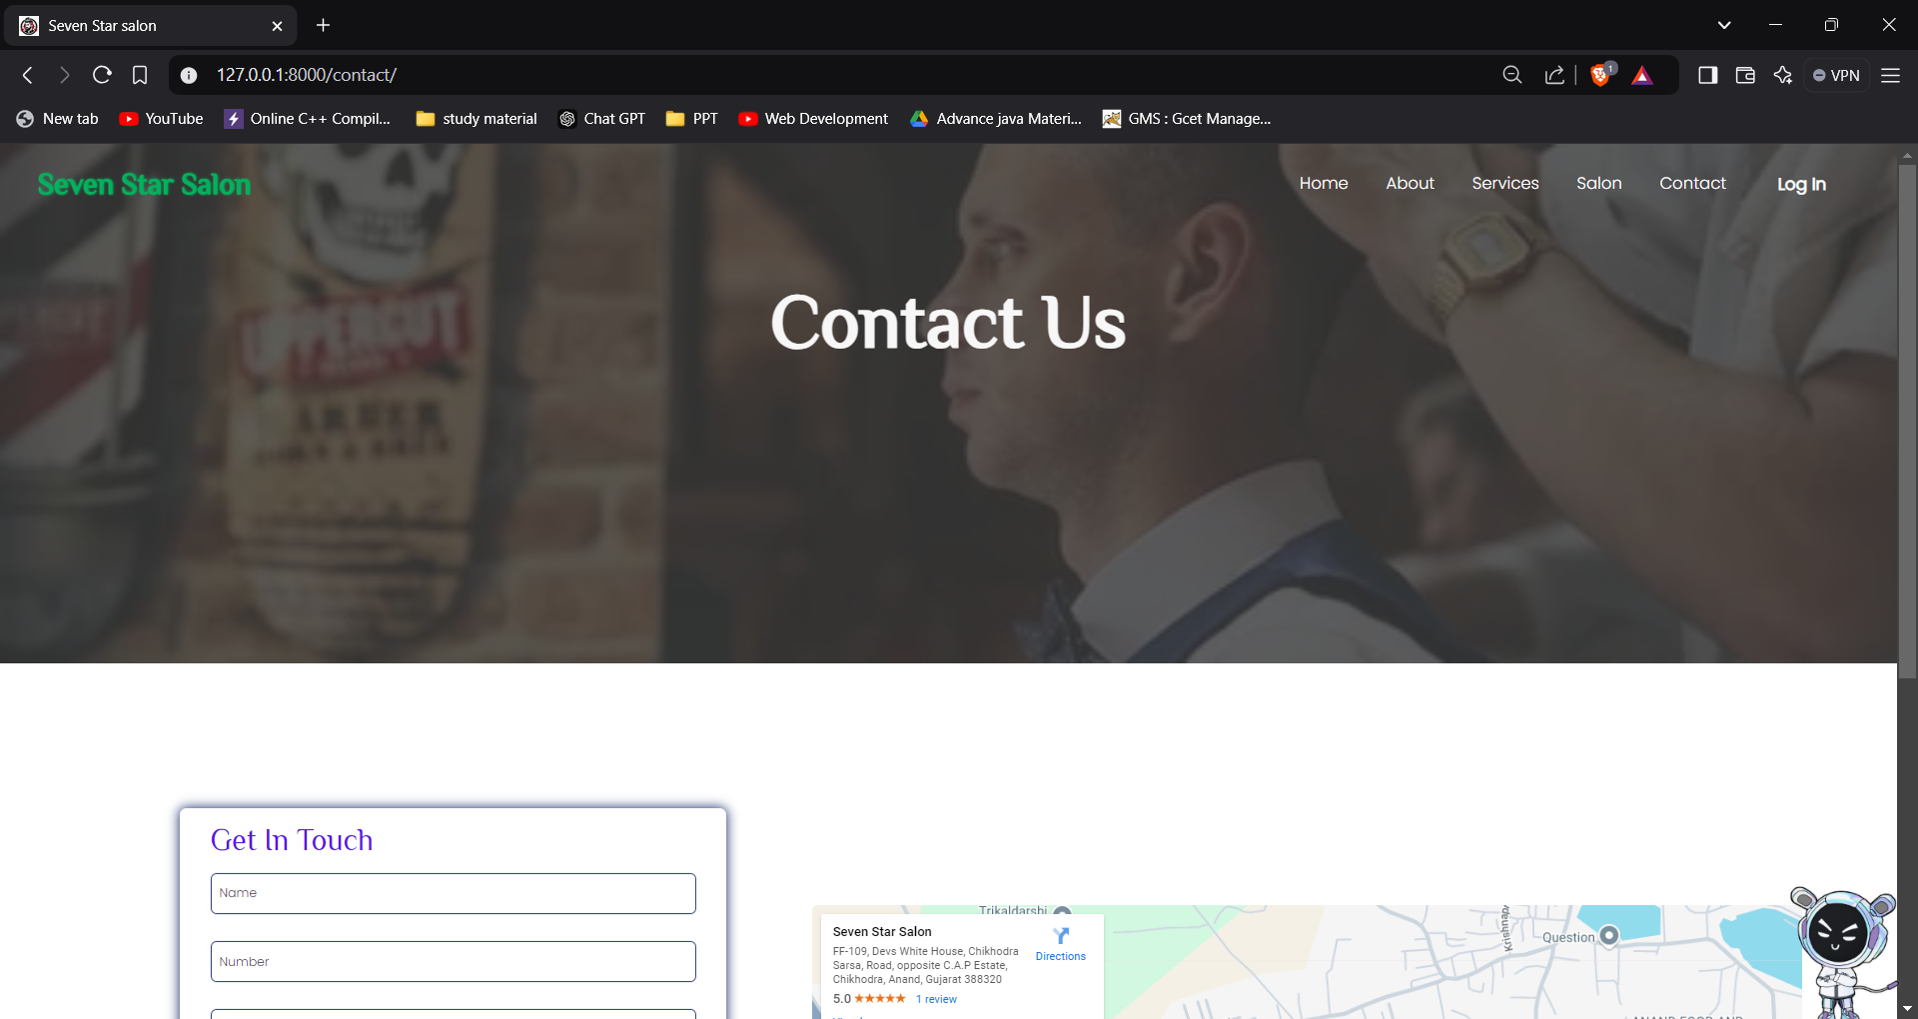

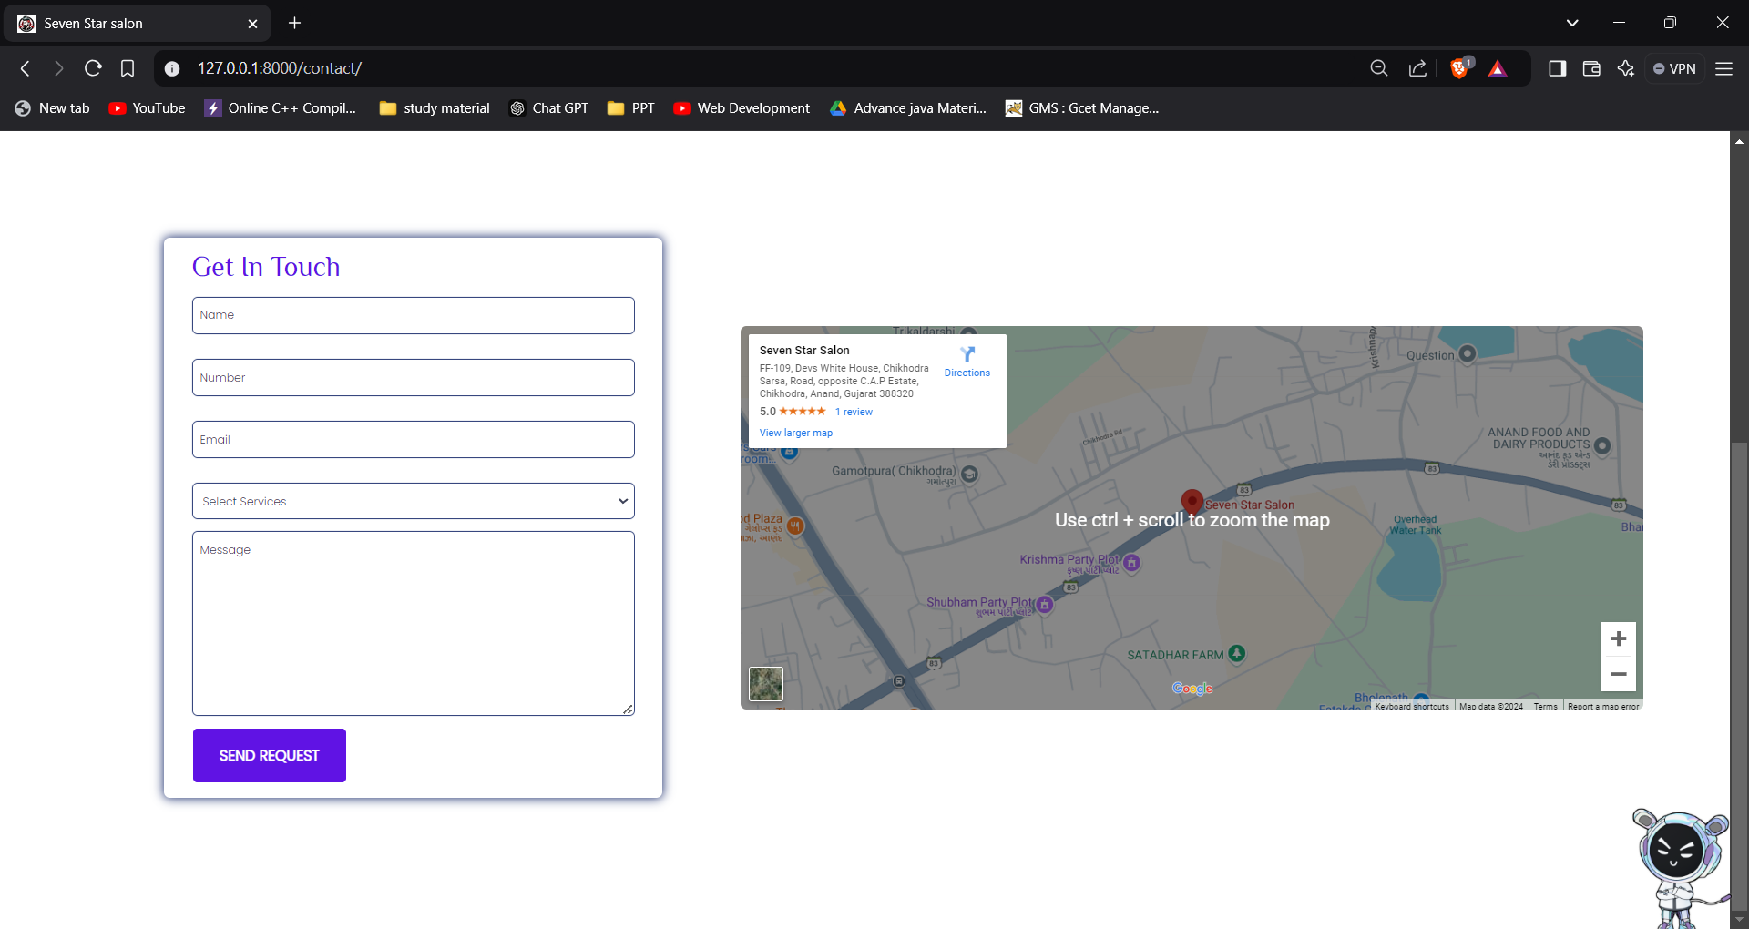

1. **Profile(profile.html)**

### Introduction

The **User Profile** page for "Seven Star Salon" provides users with a consolidated view of their personal information and account settings. The page is designed for easy access to user details, allowing them to view, update, or delete their account information in a straightforward interface.

### Page Features

1. **Header Section**:
   * Includes a navigation bar at the top of the page for seamless site navigation.
2. **Profile Overview**:
   * **Profile Picture**: Displays a placeholder avatar to represent the user visually.
   * **Personal Information Table**: Organized in a table format, displaying key user details like:
     + First Name
     + Last Name
     + Username
     + Birthdate
     + Mobile Number
     + Email
3. **Action Buttons**:
   * **Update Button**: A link that redirects users to the update page, where they can modify their details.
   * **Delete Button**: Allows users to delete their profile, with a confirmation prompt to prevent accidental deletions.
4. **JavaScript Alert for Updates**:
   * Uses JavaScript to display an alert confirming successful updates to user details.
   * Automatically redirects users to the home page after the alert for a streamlined experience.
5. **Footer Section**:
   * Includes a footer for consistent styling across pages.

The **User Profile** page is both informative and user-friendly, with all necessary information and controls in one place, making it easy for users to manage their account details. The addition of a confirmation dialog and post-update alert provides an added layer of feedback for user actions.

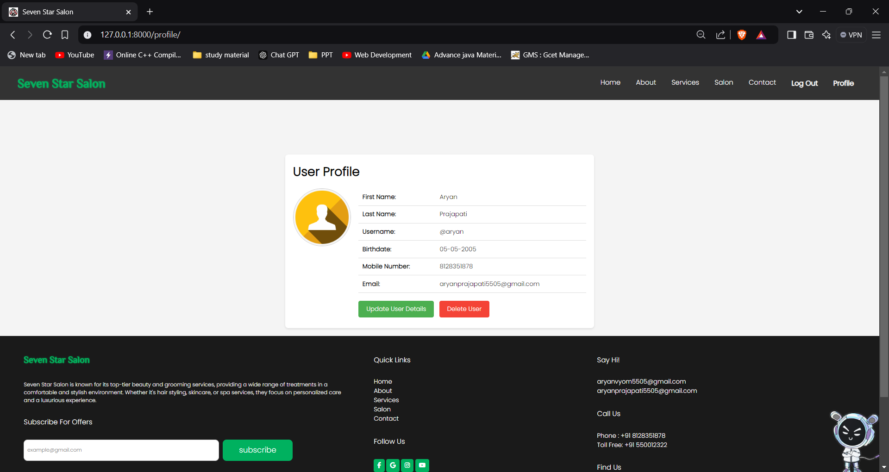

1. **Update Profile(update_profile.html)**

### Introduction

The **Update Profile** page for "Seven Star Salon" allows users to modify their personal information. This page is designed to enable users to update key details like their name, birthdate, contact information, and email, keeping their account information current and accurate.

### Page Features

1. **Header Section**:
   * Includes the site’s navigation bar for easy access to other sections of the website.
2. **User Profile Update Form**:
   * **Profile Picture**: Displays the user's profile image, which can be updated if the functionality is added later.
   * **Personal Information Fields**:
     + **First Name**: Editable text field pre-filled with the current value from the session.
     + **Last Name**: Editable text field with the current last name.
     + **Username**: Displayed as static text since it is typically not editable.
     + **Birthdate**: Editable text field, with a placeholder format for date input (dd-mm-yyyy).
     + **Mobile Number**: Editable field with a validation pattern to ensure only 10-digit numbers are entered.
     + **Email**: Editable field for updating the user’s email address.
3. **Action Buttons**:
   * **Cancel Button**: Allows users to cancel the update process and return to their profile page without making changes.
   * **Update Details Button**: Submits the form and updates the user details in the session or database.
4. **Security**:
   * **CSRF Token**: Ensures that the form submission is secure by including the {% csrf_token %} tag, which protects against cross-site request forgery attacks.
5. **Footer Section**:
   * Includes a footer with consistent styling, matching the rest of the website.

This **Update Profile** page is user-friendly, ensuring that users can easily modify their details while being guided with helpful validation messages (like for mobile numbers). The form is organized, and the buttons provide a clear way to cancel or confirm changes.

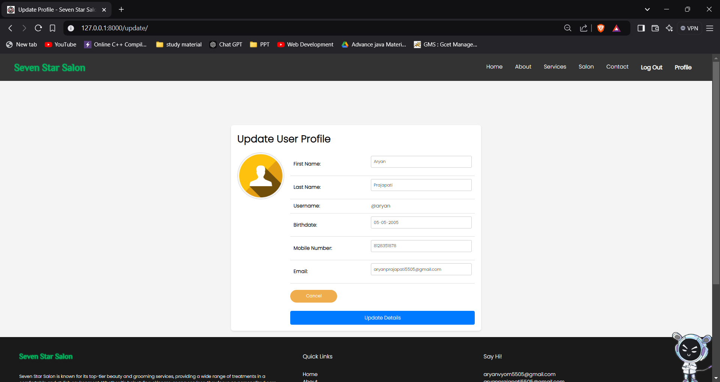

## System Workflow:

• **User Registration**:

* New users visit the **Signup** page and enter their details (name, email, password, etc.).
* The system stores these details securely in the database.
* A confirmation message is shown upon successful registration.

• **User Login**:

* Registered users visit the **Login** page and enter their credentials.
* The system checks the credentials. If correct, it grants access and redirects to the user dashboard (profile or services page).

• **User Profile**:

* Logged-in users can view and update their personal information (name, email, mobile number, etc.) on the **Profile** page.
* Users can edit details and submit changes. A success message is shown after updates.
* Option to **delete** the account is available, and the user can confirm deletion.

• **Services Page**:

* Users can view available salon services (e.g., Hair Cut, Hair Wash, etc.) on the **Services** page.
* Each service includes a description and image to help users make informed decisions.

• **Contact Us**:

* Users can fill out the **Contact Us** form to inquire about services, book appointments, or ask questions.
* Submitted requests are stored, and users get a confirmation message upon successful submission.

• **Discount Offers**:

* The website displays available discount offers in a dedicated section, which can be seen by users on various pages (e.g., Services, Salon).

• **Session Management**:

* The system maintains user sessions to keep track of logged-in users and display their details (e.g., first name, last name) across the website.

• **Navigation**:

* The website has a consistent navigation bar allowing easy access to various pages (Home, Services, Contact, Profile, etc.).

## Project Structure:

## 

## Conclusion:

The **Seven Star Salon** website offers a comprehensive and user-friendly platform for clients to explore and book salon services with ease. Through intuitive navigation, users can access various sections such as **Services**, **Profile**, **Contact Us**, and **Discounts**, providing a seamless experience from browsing services to booking appointments. The ability to register, login, update profile information, and contact the salon ensures that users can manage their interactions conveniently.

The system's use of secure session management and data handling ensures that user information is protected, while features like real-time updates and a responsive design enhance the overall user experience. The integration of discount offers further incentivizes users to engage with the salon services, creating value for both the business and its customers.

Overall, this project serves as an efficient and modern solution for managing client interactions and delivering a smooth, digital experience for salon services, supporting both the business's goals and customer satisfaction.